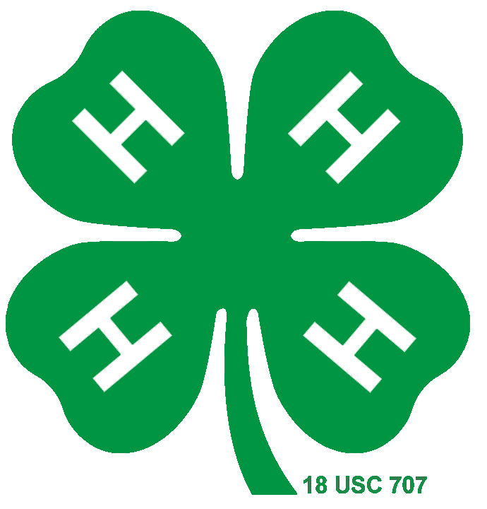
COLLEGE OF AGRICULTURAL, CONSUMER & ENVIRONMENTAL SCIENCES
University of Illinois | U.S. Department of Agriculture | Local Extension Councils Cooperating University of Illinois Extension provides equal opportunities in programs and employment.

2023-2024 – Livestock Birth, Ownership and Tattoo Dates for Illinois State Fair Junior Show
For complete Rules, Regulations, and nomination forms for Premiere Shows, please refer to the information from Dan Jennings.

STEERS:
- Calved on or after January 1, 2023
- Owned & personally cared for by exhibitor since – February 1, 2024
- Weighed, Tattooed, and EID tagged
  - On or between the last Saturday in January (January 27, 2024) and February 29, 2024.

BARROWS: Regular Barrows
- Farrowed on or after January 1, 2024 and must be the property of the exhibitor by June 1, 2024.
- No weighing and tattooing required but must submit ear notches when making entry for ISF

BARROWS: Premiere Barrows (carcass class)
- Farrowed on or after February 10, 2024 and must have been the property of the exhibitor by June 1, 2024
- Weighed and Tattooed with Box A tattoo from February 10 to April 15, 2024
- Tattooed within 35 days of birth and not weigh more than 1.0 lbs/day of age
- Junior exhibitors can purchase pre-nominated barrows

SHEEP Market Wethers & Market Ewe Lambs: Live Show Wethers.
- Lambed on or after January 1, 2024
- Ownership Date – May 15, 2024
- Self-nomination as follows: Nominations must be signed by local Extension Office.
- Exhibitors fill out and send in nomination form with photo of lamb’s ear with scrapie tag installed in ear (close up photo of ear so scrapie tag can be read). This must be completed between March 15 and May 15, 2024. Send to Dan Jennings, Region 1 Office, 1100 E., Warrenville Rd., Suite 170, Naperville, IL 60563.

Jr. and Open Premiere Wether & Ewe lambs: - Weigh-in, tattoo, and nomination procedures:
• Junior and open premiere lambs will be nominated, tattooed, and weighed at the county level.
• Premiere lambs must be weighed and tattooed with the Box A tattoo followed by a number starting with 1 - This must be witnessed by a local Extension employee or a person they designate, such as a volunteer or local sheep superintendent.

- Completed nomination forms must be signed by the local Extension Office.
- Send nomination forms to Dan Jennings (address above).
- Ownership and nomination deadline is March 15 to May 15, 2024.
- Lambed on or after January 1, 2024.

Meat Goat Wethers: Live Show Wethers.

Wethers – Born on or after October 1, 2023
  - Ownership dates for Kids & Yearlings not in milk – May 15, 2024
  - Self-nomination as follows: Nominations must be signed by local Extension office.
  - Exhibitors fill out and send in nomination form with photo of goat’s ear with scrapie tag installed in ear (close up photo of ear so scrapie tag can be read). This must be completed between March 15 and May 15, 2024. Send to Dan Jennings, Region 1 Office, 1100 E. Warrenville Rd., Suite 170, Naperville IL 60563

2024 Breeding Animals

Birth & Ownership Dates for Illinois State Fair Junior Show

BEEF – HEIFERS AND COWS:
Heifers
  - Age requirement is from September 1, 2022 to March 31, 2024 (w/ addition of Senior Yearling class)
  - Owned and personally cared for by exhibitor since June 1, 2024

Performance Cows
  - Cows must be born before September 1, 2022 (Cow-Calf Class only)
  - Owned and personally cared by exhibitor since January 1, 2024

SWINE – GILTS:
  - Age requirement is farrowed on or after January 1, 2024
  - Owned by exhibitor since June 1, 2024

SHEEP – EWES & RAMS:
  - Age requirement for yearling ewes is from January 1, 2023 to August 31, 2023
  - Age requirement for ewe lambs is after September 1, 2023
  - Age requirement for ram lambs is after January 1, 2024
  - Owned and personally cared for by exhibitor since June 25, 2024

DAIRY – COWS AND HEIFERS:
  - No age requirements
  - Calves and Heifers – Owned since June 1, 2024
  - Cows – Owned since January 1, 2024

HORSE & PONY:
  - On or before June 1 – Copies of the ownership and/or lease papers, State Fair Entries, and one set of photos sent to Stephanie Hardy at: Illinois State Fair Entry Department, P.O. Box 19427, Springfield IL, 62794-9427. PH: 217-782-0786

DOGS:
  - Dogs must be owned or leased by June 1, 2024
  - At this time, no paperwork is required to be on file. Make entries via 4-H Fair Entry Program.

DAIRY GOATS:
  - Kids and Yearlings not in milk must be owned by exhibitor only by June 1, 2024.
  - Milking Does must be owned by exhibitor only by January 1, 2024.

MEAT GOATS
  - All meat goats (wethers and all breeding animals) are to be owned by exhibitor only by May 15, 2024.

RABBITS, PYGMY GOATS & POULTRY:
  - Animals in these species that are to be exhibited at the ISF Jr. Show must be owned by the exhibitor as indicated: Does -- By June 1 of the year exhibiting; All others -- Out of stock owned by the exhibitor prior to June 1.

Changes/Notices Regarding the 2024 Illinois State Fair Animal Exhibits
Note: This list is only a NOTICE of changes that have been made regarding various animal exhibits at the State Fair. Local Extension staff, Vocational Agriculture instructors, and exhibitors and their families should read complete rules and regulations included in the 2024 ISF Jr. Department Premium book once printed copies are received or the book is posted on the ISF website: http://www.illinoisstatefair.info/.

Quality Assurance & Ethics Certification is mandatory for all horse, rabbit, poultry, and companion animals. All county and state horse and dog exhibitors must complete QA&E Certification one time during their showing career. Those that have completed it in the past do not have to complete it again.
The YQCA program is mandatory for all dairy, beef, swine, sheep, and goat exhibitors in 4-H. Details on this program are available at your county Extension Office.

Horses – Ownership, Lease papers, photos, and Entries are to be sent in together directly to: Stephanie Hardy at the Illinois State Fair by June 1 for verification of State Fair entries. If units wish to keep copies of this information for their own shows, they should make photocopies or require the exhibitors to submit two sets of forms.

All junior exhibitors will need to pay entry fees for any/all animals entered. Fees will be due with class entries – June 1 for Horses, July 1 for all other livestock. Fees will be updated in the State Fair Premium Book.

