Fashion Revue
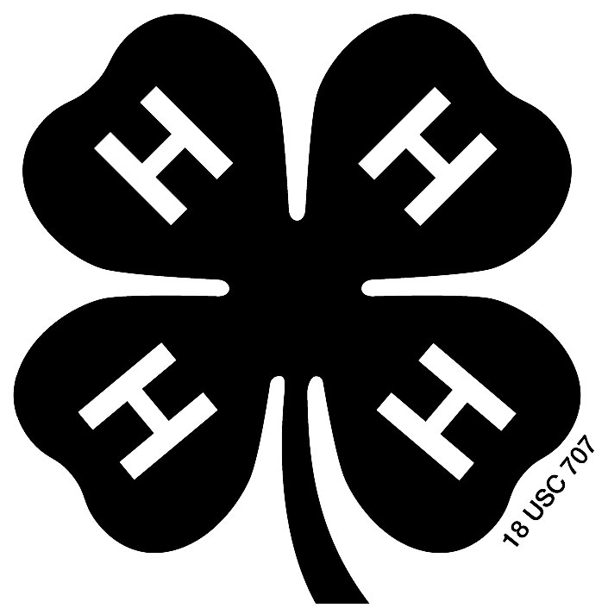
Instructions:

On the next page you will find a form to complete for the Fashion Revue. The announcer will read this description while you model your project at the Fashion Revue on Thursday. Be sure to complete the form so we have a description to read for you! This year the Fashion Revue will be in the new hospitality building by the food stand. Here are some general tips:

- Please limit your description to 100-200 words. This will give you enough time to model without having a description that is too long.
- Type or neatly print your description so it is easy to read. You may also type/write the description on another piece of paper and attach it to the form.
- Describe your outfit/item, including details on construction, style, and accessories. Suggestions of things to include:
  - Name (required)
  - Club (required)
  - Clothing project in which enrolled (required)
  - Indicate if purchased or sewn by member (required)
  - Age
  - Type of garment: casual, dressy, etc
  - Where you will wear garment
  - Fiber content of garment
  - Special interests, hobbies
  - Involvement in community activities
  - Future career plans

Examples:

________ is a 7-year member of __________ 4-H Club. She is modeling a casual summer dress she made for her Sewing and Textiles II project. This dress features a square neckline and pleated pockets. She added ties in the back for a better fit. To match the dress, _______ is wearing flat white sandals. She plans to wear this outfit to school and other casual events. This fall, 15-year-old ________ will be a sophomore at ________ High School, where she will be active in volleyball, basketball, and track. She also enjoys playing piano and babysitting. Some of her other 4-H projects include visual arts, foods, and recycling. I’m sure _________ won’t go unnoticed walking down the halls at school in this bright and colorful dress!

________ is ready for some fun in the sun in her plaid cotton Bermuda shorts, which she purchased for her Clothing Decisions project. She has chosen a classic polo shirt and brown flip-flops to complete her outfit. _______ is a 6-year member of the _______ 4-H Club and this is her first year in Clothing Decisions and Fashion Revue. She will begin her sophomore year this fall, where she is involved in volleyball, cheerleading, French club, pep club, student council, and chorus. She also enjoys hanging out with her friends and family and shopping. _______ wants to pursue a career in Food and Nutrition, and would like to attend the University of Illinois.

Name: _______________________________________________________________________

4-H Club: _____________________________________________________________________

Project (circle one): STEAM 1 2 3 Shopping in Style 1 2 3 4 5 6

Years in Project: _______________________________________________________________

Please write the description (as you would like the announcer to read it) in the box below for the outfit/item you will be modeling at the Fashion Revue. Refer to the instructions and examples for ideas of what to include. Please limit your description to 100-200 words and be sure it is neatly printed or typed. You may also type/write on another sheet of paper and attach it to this form.

Return this form to the Extension Office Table, by noon on Thursday at the 4-H Fair.

