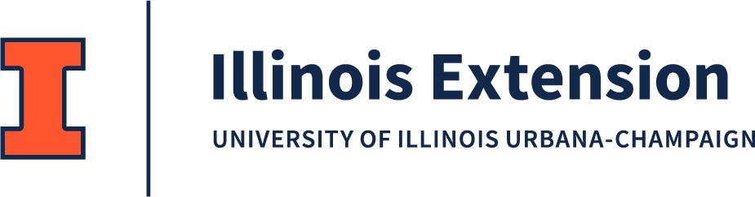

Extension Board Meeting AGENDA
- Introductions
- Event Tours and Interviews with volunteers, participants, and staff
- County Needs Discussion
- Budget Materials
  - Financial Statement

  - Rationale

  - Impact Report (To be distributed to County Board with levy request)

  - County Funding Request
- Questions, Adjourn

Meeting Locations:

Boone County: Monday, July 7, 2025—10:30 AM
Illinois Junior Chef
St. John's United Church of Christ 401 N Main Street, Belvidere, IL

DeKalb County: Monday, July 7, 2025—11:30 AM
Russell Woods Nature Camp Natural Resource Education Center 11750 State Rt 72, Genoa, IL

Ogle County: Thursday, July 31—8:30 AM
4-H Horse Show (enter and meet at South gate) Ogle County Fairgrounds
1440 N Limekiln Road, Oregon IL

Council Roles Summarized: * Linking University of Illinois Extension with local leadership, communities, agencies, and organizations.
* Supporting and advocating for Extension programs. Identifying needs and potential resources (human, financial, physical).
* Advise the program planning and implementation processes. * Assuring council membership represents all segments in counties served. * Assuring program outreach meets equal opportunity and program access guidelines.

