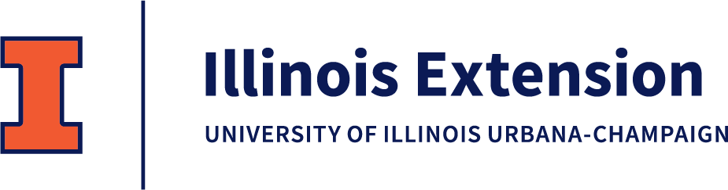
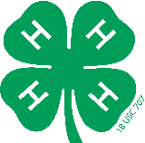
Clark County 4-H
15493 N. State Hwy 1
Marshall, IL 62441

May 1, 2023

Dear 4-H Friend,

In 4-H, youth build life skills by leading hands-on projects in areas such as science, health, agriculture, and civic engagement – helping them grow confidence, independence, resilience, and compassion. Adult mentors provide a positive environment where kids learn by doing.
Our 4-H'ers are busy preparing for this summer's 4-H Fair, and we want to recognize outstanding 4-H'ers with awards in honor of their accomplishments. To do this, we rely on the generous support of our donors.
We invite you to support Clark County 4-H in one or both of the following ways:
- Make a "Friends of 4-H" general donation. These donations will support fair awards and other local 4-H programs and are eligible for state-matching funds. Your name or business will be listed as a Friends of 4-H donor.
- Sponsor individual awards with your name or business name listed as the donor.
Please consider donating to support 4-H by completing the second page of this letter. If you cannot contribute at this time, please advocate for 4-H by sharing our mission with a co-worker or friend. Even a quick mention on your social media is appreciated.
We are proud to be a part of this community and know programs like 4-H would not be possible without you.

Sincerely,

Jennifer Bishop
4-H Program Coordinator

THANK YOU FOR SUPPORTING CLARK COUNTY 4-H
To ensure proper recognition of your support, please complete this entire form and return it to us by June 1. We will do our best to make sure your requests are filled with the award area of your choice.
Name/Business Name: _______________________________________________________________________________
Address: ___________________________________________________________________________________________
City, State, Zip: _____________________________________________________________________________________
Email Address: ______________________________________________________________________________________
Phone: ____________________________________________________________________________________________
How do you want your name to appear on the donor list? ___________________________________________________
__________________________________________________________________________________________________

Please select one or both donation options below:
- FRIENDS OF 4-H DONATION (These funds are state-matched)
_____$25 _____$50 _____$100 _____Other amount

- SPECIFIC 4-H AWARD SPONSORSHIP DONATION (Choose a project area below if you wish)
_____$25 _____$50 _____$100 _____Other amount

General Project Areas Livestock Project Areas
If the project area you choose has enough donations, may we move your donation to a state-matched donation?
_____YES _____NO
_____Poultry
_____Rabbits
_____Sheep
_____Swine
_____Showmanship
_____Beef
_____Dairy
_____Dogs
_____Goat
_____Horse
_____Aerospace
_____Animal Science/Small Pets
_____Cats
_____County Exploration
_____Crops
_____Floriculture
_____Foods (5 awards)
_____Geology
_____Horticulture

PLEASE RETURN THIS FORM WITH PAYMENT BY JUNE 1, 2023
_____Leadership
_____Robotics
_____Seamstress
_____Shooting Sports
_____Shopping in Style
_____Tractor/Small Engines
_____Visual Arts
_____Veterinary Science
_____Woodworking
MAKE CHECK PAYABLE TO: University of Illinois Extension, Clark County
MAIL TO: University of Illinois Extension, Clark County, 15493 N. State Hwy 1, Marshall, IL 62441

