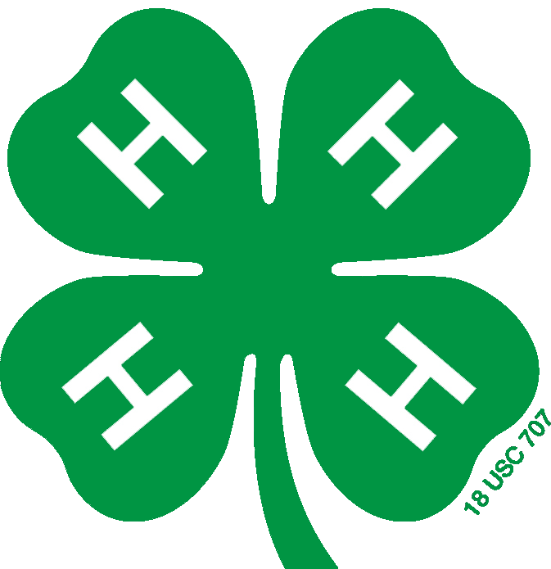

**Boone County**

Gina DelRose

Brooke Glander

Heather Nelson

Amy Hildebrant

Jael Monteagudo

Dakota Schober

Jane Zeien

**DeKalb County**

Pat Alexander

Desiree Corral

Ellie Davis

Dori De La Cruz

Joe Dombek

Noe Escamilla

Lillian Hetland

Araceli Lopez King

**Ogle County**

Carson Conderman

Chelsea Eden

Jody Hayes

Bode Martin

Jeannette Mingus

Gracie Prose

**4-H Staff**

Johnna Jennings - BDO

Kathy Dombek - BDO

Melissa Irwin - Boone

Nicole Groezinger - DeKalb

Jodi Baumgartner - Ogle

**Committee Members**

**4-H Expansion and Review**

**Boone, DeKalb & Ogle 4-H**

**May 23, 2023**

**Zoom at 7:00 p.m.**

**Welcome**

**Introductions**

**Program Updates**

**Needs Assessment Survey**

**Next Meeting Dates**

September 26 - in person at Fatty’s Pub & Grille in DeKalb

**Adjourn**