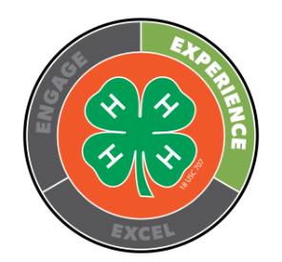
White County Club Officer Award Guidelines

President —Include Essay
Did the essay:
- Include examples of personal leadership in preparing the club agenda, planning programs, assisting members, holding officer meetings, etc. which give a clue insight into the president’s leadership role as president.

Secretary—Include Secretary book
Submitted Secretary Books
- The roll should be complete for each meeting. It is preferred the list be completed as the year progressed, NOT rewritten at the end of the year. This is the official record of who attended and should not be rewritten at the end of the year to “look pretty” since errors could happen in the transferring of books.
- Minutes may be handwritten in ink in the book itself or typed and the pages inserted in the book in some fashion. Minutes should have complete motions, seconds and results of votes, etc.
- Approval for minutes should follow at the next club meeting and can be a vote of the club, or approval from the club leader
- A complete list of club officers and leaders (pg. 3) should be included.
- A complete list of committees (pg. 4) should be included and complete
- Additional club activities should be listed in the back for events that occurred outside the club meeting.

Treasurer—Include Treasurer’s book, including bank statements & receipts
Does the treasurer’s book
- Include a complete financial statement and audit. The audit must be completed by a member, parent and leader who are not affiliated with the club’s treasurer.
  - Is the FEIN correct?
  - Do the totals balance?
  - Do the totals match the record of club finances which follow it?
- Include receipts to match all expenditures of the club?
Do the bank statements match the treasurer’s records?

Office Reporter—no submission, material at office
- Is there a form for each meeting?
- Is the form complete?
- Was the form sent to the office in a timely manner?

News Reporter—if possible, include actual copy of story which appeared in paper
- Are the stories well written?
- Do they contain all the information necessary?
- Are they entertaining and enjoyable to read?
- Is the information correct?

