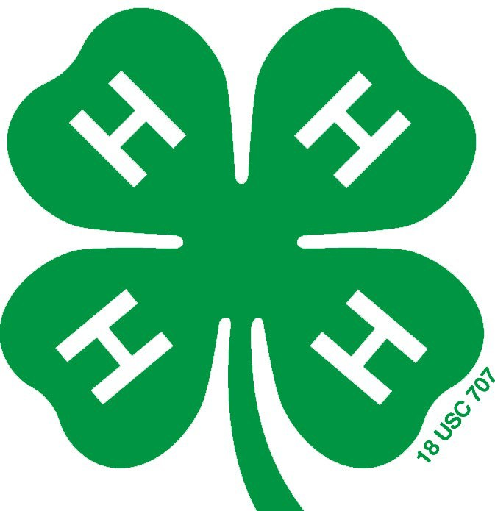

FULTON COUNTY

4-H AWARDS

MANUAL

The 4-H awards application is a form that a 4-H member completes if he or she wants to compete for county 4-H awards that are presented at our 4-H Achievement Program each Fall. As of 2020, the same form is used for all ages.
The award application is available at the Extension Office and on our website. Leaders are encouraged to obtain forms for their entire club, at any time of the year. Members may also request them from the office themselves. They are also on our website, extension.illinois.edu/fmpt/4-h-fulton-county. All members enrolled in 4-H may apply for awards.

Deadline
4-H members are encouraged to work on their awards application all through the year. The completed application form must be submitted to your club leader in early August. Your leader will review your application, and you or your leader must turn it in to the Extension Office by the last Monday in August. Absolutely no award applications are accepted after this date.

What Can Members Win?
Members can win plaques, trophies, certificates, practical items, and more. To compete for county awards, an application must be submitted. Those winning awards will be recognized at the Achievement Program in the fall.

This manual includes all the rules and guidelines for completing an awards application, as well as a list of what awards are available. Please read them carefully, and always feel free to call the Extension Office at 547-3711 with any questions, or email Krista Gray (kristakg@illinois.edu) or Rachel Van Cleve (rfv@illinois.edu).

COLLEGE OF AGRICULTURAL, CONSUMER & ENVIRONMENTAL SCIENCES
University of Illinois | U.S. Department of Agriculture | Local Extension Councils Cooperating University of Illinois Extension provides equal opportunities in programs and employment. If you need a reasonable accommodation to attend, call the registration office. Issued in furtherance of Cooperative Extension work, Acts of May 8 and June 30, 1914, in cooperation with the US Department of Agriculture by the Director, Cooperative Extension Service, and University of Illinois.

County Awards Competition

To be eligible to apply for a County Project Award, the following requirements must be met:
- The 4-H member must meet the standards for project achievement by doing the following:
  - Member must attend at least two-thirds of the club meetings after joining. Leaders may authorize excused absences.
  - Member must turn in 4-H records. 4-H records can mean any of the following:
    - Project goal sheets and My 4-H Activities sheet
    - 4-H award applications
    - 4-H project manuals that have sections for filling in information, answers, etc.
  - Member must share project experiences by giving a talk or demonstration or making an exhibit in that project area.
- The 4-H member must be currently enrolled in one or more projects listed for the award area.
- An award application must be completed by the member, signed by the leader, and submitted to the Extension Office by the deadline (the last Monday in August).
- The club leader must review and submit the members' award applications to the Extension office by the last Monday in August, for review by the County 4-H Youth Committee. Leaders cannot refuse to submit an awards application unless
the information reported is false. Members may turn in their own award applications, but they must be signed by the leader.
- Project financial records are not to be turned in to the county with the awards application.

State Awards Competition
As of 2020, State 4-H is no longer presenting traditional 4-H awards, but instead is giving more 4-H scholarships. Contact the Extension Office for complete information, or visit the Illinois 4-H website. Watch the 4-H Newsletter for due dates, which are typically announced in the early fall.

RULES FOR COMPLETING THE AWARDS APPLICATIONS
- Please read carefully the information found in this manual, and any information printed on the awards application forms. Award applications should show information from only the current 4-H year.
- The 4-H Youth Committee will evaluate all award applications submitted by
the deadline. Award applications not at the Extension office by the last Monday in August will not be judged, and are ineligible for awards of any kind.
- The number of county awards given in each program area will be determined by the 4-H Youth Committee. This number is based on funds available and the number of qualified applications each year.
- This application should include 4-H and non-4-H activities. Follow the instructions on the award application, and include any information requested in each section. You will need to write one essay (story) for each award you are applying for.
- You may hand write directly onto the application form, type it, or prepare the same exact information on a computer and print it out on white paper. If you prepare the information on white paper, include the charts and all the information requested. It is acceptable for someone else to type the form or prepare it on computer from your handwritten version. However, if the application is handwritten, the member must do it in his or her own writing. No parent handwriting! You may add pages.
- Neatness, grammar, and spelling are VERY important. Remember to proofread for errors.

- Each essay should follow the guidelines in the heading, including any information requested. Read the essay instructions CAREFULLY.

- All information on the awards application must be true.

AVAILABLE 4-H AWARDS

As of 2020, State level 4-H awards are no longer available. Instead, there are more 4-H scholarships being offered through the State 4-H Office.

County level 4-H awards are available in the following areas:
Name of Award Area Projects Included In This Award Area
Aerospace Aerospace
Beef Beef
Beekeeping Beekeeping
Bicycle Bicycle
Child Development Child Development
Civic Engagement Civic Engagement, Service Learning, Exploratory (Welcome To
4-H, Collectibles)
Communication Arts Journalism, Public Speaking, Communications,
Filmmaking (Video), Creative Writing
Computer Science Computer Science
Dairy Dairy Cattle

Dog Care and Training Dog
Electricity Electricity
Energy Management Small Engines; Tractor; Robotics; Welding
Entomology Entomology
Family and Consumer Entrepreneurship, My Financial Future, Build Your Future,
Family Heritage
Floriculture Floriculture
Food-Nutrition All Foods projects
Forestry Forestry
Geology Geology
Goat Dairy Goat, Meat Goat
Health Health
Horse Horse
Horticulture Vegetable Gardening
Intercultural Passport To the World, Diversity and Cultural Awareness
Interior Design Interior Design
Leadership Leadership
Natural Resources Exploring Your Environment, Natural Resources,
Outdoor Adventures, Sportfishing, Wildlife, Shooting Sports
Performing Arts Performing/Theater Arts
Photography Photography
Plant and Soil Science Corn, Small Grains, Soybeans, Plants and Soils

Name of Award Area Projects Included In This Award Area
Poultry Poultry
Rabbit Rabbit
Sewing and Textiles Clothing, Shopping In Style
Sheep Sheep
Small Pets Cat, Guinea Pigs, Small Pets
Swine Swine
Technologies Drones, Maker, Esports
Veterinary Science Veterinary Science
Visual Arts All Visual Arts projects
Weather Weather 1, 2, 3
Wood Science Woodworking

"Best of" Awards

One outstanding member may be chosen each year in the following categories:

Best of Beef
Best of Dairy Cattle
Best of Goat
Best of Horse
Best of Poultry
Best of Rabbit
Best of Sheep
Best of Swine
Best of the Arts (for Photography, Visual Arts, and Performing/Theater Arts)
Best of Communications and Business (for Civic Engagement, Communication Arts, Computer Science, Intercultural, Technologies, Public Presentations, and Leadership)
Best of Crops and Horticulture (for Floriculture, Horticulture, Plant & Soil Science)
Best of Family Life (for Family and Consumer, Health, and Interior Design)
Best of Foods (for Food-Nutrition projects)
Best of Mechanical Sciences (for Aerospace, Bicycle, Electricity, Energy Management, and Wood Science)
Best of Natural Resources (for Entomology, Forestry, Geology, Natural Resources, and Weather)
Best of Sewing and Textiles (for Sewing and Textiles projects)
Best of Small Animals (for Dog Care and Training, Small Pets, and Veterinary Science)

SPECIAL AWARDS
To compete for the following special awards, a special, separate application form must be completed. The forms are available from the Extension Office, and on our website, and leaders or members may obtain copies at any time. These are also due at the Extension Office by the last Monday in August each year.
Outstanding First Year Member Award - Any 4-Her who is completing his or her first year in 4-H may apply for this award.
“I Dare You” Award - Recipients of this award will receive the book, “I Dare You.”
The award is based on the 4-Her's leadership, scholarship, physical fitness, and character. A 4-H member may win this award only one time. This is for 4-H members age 15-18 as of the 4-H year just completed.
Reporter of the Year - Each club may submit the club reporter's scrapbook for judging. No application form is required.
Secretary of the Year - Each club may submit the club secretary's book for judging.
No application form is required. These books are required to be turned in, whether or not they are being judged.
Treasurer of the Year - Each club may submit the club treasurer's book for judging.
No application form is required. These books are required to be turned in, whether or not they are being judged.
Hilda Rock Memorial Cooking Award - Goes to the 4-Her(s) with the outstanding third year foods project, who plans to continue with 4-H foods projects in the future. To be
considered for this award, request an application form from the Extension Office. The form is also on our website.

CLUB AWARDS:
Traveling Community Service Award - A plaque is presented to the club doing the most work in community service in the current 4-H year.
Traveling Health and Safety Award - A plaque is presented to the club doing the most work in health and safety in the current 4-H year.
Clubs can also apply for State Awards in several categories, with applications due each year in late July or very early August. Contact the Extension office for more information.

There are other state 4-H award opportunities, based on a 4-H member’s experience. Contact the Extension office for more information, or visit the Illinois 4-H website.

Call the Extension Office at 547-3711 with any questions, email Krista Gray (kristakg@illinois.edu), Rachel Van Cleve (rfv@illinois.edu), or visit our website at extension.illinois.edu/fmpt/4-h-fulton-county.

Fulton County 4-H Award Application
(for all 4-H members)

Must be in 4-H member’s own handwriting or prepared on computer.

You may print directly onto the application form, type it, or prepare the same exact information on a computer and print it out on white paper.

It is acceptable for someone else to type the form or prepare it on computer from your handwritten version. However, if the application is handwritten, the member must do his or her own writing. Refer to the 4-H Awards Manual in the back of the 4-H Show Book for complete rules and details.

Name Birthdate: Month Day Year
4-H Club

I want to apply for 4-H awards in the following project award areas. I have written an essay for each one of these –

STATEMENT BY MEMBER

I have personally prepared this application and certify that it accurately reflects my work.

Signature of 4-H Member Date

APPROVAL OF THIS APPLICATION

I have reviewed this application and believe it to be correct.

Signature of 4-H Leader Date

Section 1 – 4-H Project/Program Summary
Age

List the 4-H projects you have taken this year. Tell about what you have done in each project this year. List things like number of animals, how many dishes you prepared, how many items you have made, events you helped plan, times you taught something, exhibits, talks and demonstrations, how you have helped others, etc.
Name of Project | What I Did In This Project In This 4-H Year

Section 2 – Participation In Other Community/School Activities and Events
List your participation in sports, band/chorus, school clubs, drama, other youth organizations, religious groups, etc., from this year. Tell what skills you have learned. How did you help others?

Kind of Activity | What I Did and Skills Learned

Section 3 – Participation In 4-H Events and Activities
List 4-H events you have participated in -- trainings, workshops, classes, field trips, clinics, special events with your club or county, and list what you learned. Also list offices you held or committees you served on. List only those from this 4-H year. Do not include 4-H show results.

Kind of Activity | What I Learned

Section 4 -- Essay
Write a separate essay (story) for each award you are applying for.
One story per page. If you are applying for an award in four different project areas, you need four separate essays.
Include things like –
*skills developed in the projects
*what you have accomplished by using those skills to teach others
*how you have given back to your community
*how you have shown leadership, how you have helped others
*how you continue to learn
*what goals you have set and achieved

*What does being in 4-H mean to you?
You may also include the impact of the work you have done – how has your 4-H work made a difference in the lives of people in your community? Only include information from the current 4-H year. You may add pages.

