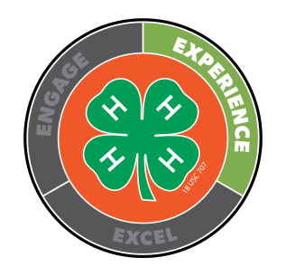
White County Health Award

Name Club
Date of Birth Your Age on Sept. 1, 2023
Years in 4-H Sept. 1, 2023 – August 31, 2024 Award Year
There are two divisions for this award:
Junior (age 8-12)
Senior (age 13-18)
Cash prizes are awarded for 1st – 3rd places in each division.

INSTRUCTIONS: To apply for the Health Award:
- Complete as many activities listed below as possible and record the date you completed them. The activities should be from this year.
- Turn in a written report about at least one of the activities you did.

TOPIC DATE COMPLETED

- Take a Health 4-H Project and show your project at the 4-H Show.
- Make a First Aid Kit for your car, house or classroom
- Baby-proof your home or a friend’s home.
- Learning about where germs hide and how to avoid them
- Sharing information about hair, skin, nails, teeth, ears and eye care.
- Recognizing nutrient rich "power foods" and add them to your diet
- Create and eat healthy snacks
- Give a speech or demonstration at your club meeting about a health issue.
- Learn how eye glasses work.
- Have a health exam at your local doctor.
- Have an eye exam at your local optometrist.
- Have a dental exam at your local dentist.
- Complete a self-assessment of your current fitness status
- Keep track of how much food you eat and how much water you drink
- Design your own fitness plan.
- Discuss the importance of proper stretching before exercising
- Participate in a 3K, 5K or 10K run
- Attend a sports training camp.
- Participate in summer sports activities
- Participate in school sporting activities
- Organize a health fair for your community or school
- Attend a health fair
- Study health in school
- Make a container of your own antiseptic Wash (Book 1)
- Learn to perform the Heimlich
- Study bugs and insects which might be poisonous to humans
- Conduct a poison look-alike activity in your club or classroom
- Have a speaker about a health issue at your 4-H club meeting
- Do a speech about the need for hydration when you exercise
- Eliminate a less healthy food from your diet
- Calculate your BMI (Body Mass Index) (Book 3)
- Learn about the dangers of using drugs and alcohol
- Discuss a time you made a healthy choice over an unhealthy choice
- Record your heart rate before, during and after an exercise routine
- Take a bicycle safety course
- Learn about disabilities
- Practice saying no in an unhealthy situation
- Simulate a car crash to illustrate the use of safety belts
- Learn about other cultures
- Develop a list of traits you find admirable in your friends
- Discuss strategies for handling depression
- Write a health related public service announcement
- Write a letter to your congressman about a health issue
- Learn about the effects of tanning on your body
- Survey your friends about what precautions they take when in the sun and write a report about your results
- Discuss how cancer has effected your family
- Create a personal health log
- Keep a stress diary
- Care for an “egg” baby
- Interview professionals about a health career
- Other

