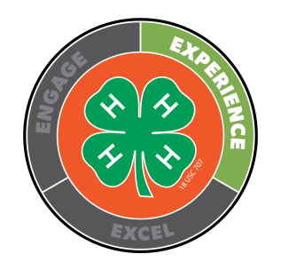
White County Club Community Service Award Application

Name of Club ___________________________________________________________

Leaders’ Names ___________________________________________________________

$200 cash prizes are awarded to clubs who demonstrated outstanding community service projects during the 2023-2024 4-H Club year. In the space provided, provide a summary of the special service projects your club has done. Be sure to include any cost the club incurred, outside groups involved with the project and the number of people involved in the project. You may use the back of this sheet.

Submitted By __________________________________

