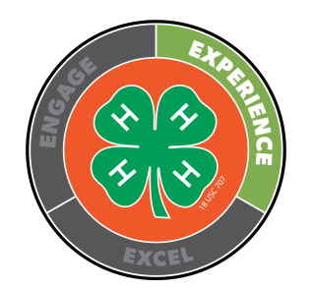
White County HCE Home & Family Award Application

Name Club
Date of Birth Age on Sept. 1, 2023
Years in 4-H Sept. 1, 2023 – August 31, 2024 Award Year
There are two divisions for this award:
Junior (age 8-12)
Senior (age 13-18)
Cash bonds are awarded to one Junior and one Senior winner.
You may only win this award once per age division.

INSTRUCTIONS:
- Write and attach a story about the topic listed below:

What homemaking activities did you take and do this year and what did you learn? How did this add to the homemaking projects you have taken in past years?

- Submit your 4-H Highlights form.

- Include signatures from the member, parent and leader.

I have prepared this application and certify that it is an honest account of my work.
4-H Member’s Signature

I have reviewed this application and believe it to be an honest review of the 4-Her’s work.

4-H Parent’s Signature

4-H Leader’s Signature

